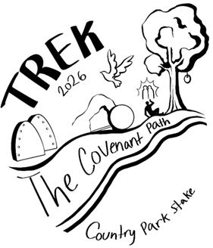
Packing for Trek
All of your gear for the pioneer trek will be packed in one of two containers:
1. In your 5-gallon bucket (screw tops work best) and 2. In a large, heavy-duty garbage sack. The bucket will contain your personal items and clothing. The garbage sack will contain your sleeping items. Remember to label everything with your full name and ward number.
You will also need to bring a sack lunch that does not require refrigeration for the first day.
What to pack in your garbage bag:
- Warm Sleeping bag (temperatures may get <40 degrees at night)
- Small camp pillow
- Small sleeping pad or small/thin air mattresses which does not require electricity
- Extra blanket (optional)
- Warm coat or jacket
What to pack in your bucket:
- Rain poncho or rain jacket
- Plastic or metal plate, cup, and utensils
- Refillable water bottle (bring a carabineer or something to clip onto cart)
- 2 pairs of athletic-type or hiking shoes that are sturdy and well broken in
- 3-4 pair wool blend socks
- Moleskin for blisters
- 2-3 sets of underclothing
- Pajamas or sweats (To be worn at night/bedtime)
- 1 pair of soft leather gloves
- Hand towel or wash cloth
- Comb or brush
- Toothbrush and travel size toothpaste
- Deodorant
- Sunscreen-SPF 30+ - The Stake will provide SPF 15 Lip Balm but you can bring another if you like
- Insect Repellent
- Headlamp or small flashlight
- Sunglasses (Inexpensive)
- If you wear contacts, you may want to wear glasses-there will be a lot of dust.
- Small hand sanitizer
- 1 travel size package of wet towelettes
- Any prescription medications you need
- Old small set of scriptures
- Pen or pencil

Young Women Should Bring (pack in bucket):
- 2 mid-calf, long-sleeve dresses, or skirts and blouses, (wear one, pack one)
- Wide brim straw type hat with a tie or chin strap as the wind does blow
- 1-2 aprons with pockets
- 2 pair of leggings or yoga pants no bloomers
- Feminine hygiene supplies
- Hair elastics or fasteners
Young Men Should Bring (pack in bucket):
- 2 pair of loose-fitting cotton, docker type pants (no denim, no camo pants, no shorts),
wear one, pack one
- 2 long sleeve, collared, button shirts (no-t-shirts)
- Wide brim straw/canvas/western style hat (no baseball type hats) – Ties or chin straps recommended, the wind does blow
- Suspenders (optional)
- Vests (optional)
Do not bring:
- Valuables such as jewelry
- Make-up, perfume, scented lotions, hairspray, cologne (bugs love it!)
- Knives, guns or other weapons, matches, lighters, footballs, Frisbees, or card games, etc.
- Electronics or cell phones

