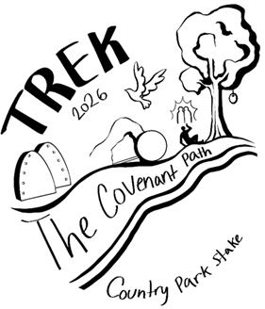
2026 Country Park Stake Trek Theme:
THE COVENANT PATH -
MY OWN PERSONAL TREK
Scripture: Doctrine and Covenants 84:88
88 And whoso receiveth you, there I will be also, for I will go before your face. I will be on your right hand and on your left, and my Spirit shall be in your hearts, and mine angels round about you, to bear you up.

THE COVENANT PATH - MY OWN PERSONAL TREK
Our goal is to strengthen testimonies of Jesus Christ and His gospel through pre-Trek activities, as well as the events and experiences on Trek. We want to help the youth focus on the myriad TREKS which are found throughout the scriptures and understand how they can apply the lessons and teachings from those TREKS to their own life. We aim to show the youth how the experiences of people from the past can correlate with the joys, trials, and hardships of modern life. This application will bring a greater understanding of the Atonement of Jesus Christ, leading to a strengthening of their relationship with Him and a desire to cleave to the Covenant Path, the Principles of the Gospel, and the Laws of the Covenant. Helping them to see and receive the blessings associated with making and keeping these eternal covenants with our Father in Heaven. We will all have the opportunity to feel and better understand what the pioneers and scriptural personages felt and experienced, as they decided to push through and stay on the Covenant Path despite the trials and hardships they were enduring. Everyone joining us on trek will be able to discover the truth about their abilities, Divinity, and the strength that comes through reading, understanding and applying the scriptures to their own life. Our prayer is that they are inspired to act and apply the lessons and skills they gain, to improve their life through an increased love of the scriptures, Our Father in Heaven and His son Jesus Christ.
Goals for Trek

- gain understanding and appreciation of all of the TREKS throughout the Standard Works.
- have opportunities to feel the Spirit and strengthen your testimony of the Savior and his sealing power.
- more fully understand and apply the principles of faith, sacrifice, and perseverance.
- learn from the past, to gain strength and courage for the future.
- commit to immerse themselves in a lifelong pursuit of reading, pondering and loving the scriptures and the testimony that they give of the Divinity of Jesus Christ.
